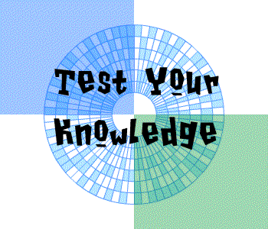

**QUIZ NIGHT**

IN

SHORNE PARISH CHURCH

SATURDAY 21 SEPTEMBER 24

Arrive 6.30pm for 7pm start

***PRICE £5 per person***

***Teams of 6 to 8 maximum***

To book a table ring Sue Crawford on

07852332950

*Bring your own refreshments*

SHORNE CHURCH SOCIAL TEAM

IN AID OF CHURCH FUNDS